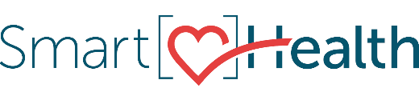
SmartHealth has partnered with Generation Wellness to offer exclusive videos and free trainings designed to promote wellness, enhance your well-being, and help you live your best life.

Just sign into SmartHealth to find these free learning opportunities from Generation Wellness:
- Workplace Wellness Academy online training course
- Wellness in the Workplace in-person training (available later this year)
- Videos that dive into a new well-being theme each month

You can earn 300 SmartHealth points and qualify for two free clock hours of continuing education for completing the Workplace Wellness Academy. Space is limited, so register soon. Watch one of these videos to learn more about the course.
- Workplace Wellness Academy
- What's Covered in the Workplace Wellness Academy

What is SmartHealth?
SmartHealth is a fun, secure, and easy-to-use tool that supports you on your journey towards well-being. As you progress on your journey, you could qualify for a $125 wellness incentive.
Learn more about SmartHealth.

Be well,

The SmartHealth Team
Supporting you on your journey toward living well

